Lewanika Pittman

Amro Tayeb

**CHAPTER I**

**INTRODUCTION**

In the current video game market, video game development has become more streamlined and accessible than ever, with free or very affordable open-source, multi-platform game engines such as Unity, Godot, and CryEngine paving the way for aspiring developers, with helpful tools that are useful to those with skills ranging from entry-level to AAA level. This project will involve a video game that will be developed in a second-person perspective, viewed in standard 3D, and ported to VR utilizing one of these open-source engines, Unity. Unity is one of the most popular development engines that has played host to a plethora of AAA games from the Angry Birds series, Hearthstone: Heroes of Warcraft, to highly rated indie games such as the physics-based simulator Kerbal Space Program. Our aspirations are to design our own game that could eventually be placed onto a digital mantle alongside such classics.

**PROBLEM STATEMENT**

The main challenge will be designing a game where the A.I. controlled character will have to be programmed with a role that would generally be assigned to the user. This will be a particularly tricky challenge because the main A.I. will need to be programmed in a manner that mimics a typical human user’s behavioral pattern and thought processes. Another challenge will be integrating the entire experience into the virtual reality spectrum. Careful attention to detail must be incorporated when developing VR such as making sure that every object is properly and fully rendered in 3D to prevent the player from losing any sense of immersion. It’s also vital to carefully develop a type of field-view camera motion to prevent any depth-of-field issues or motion sickness with sensitive users.

**LITERATURE SURVEY**

This section will give an example of game designs similar to the project that we will undergo, as well as give the reader some definitions of some of the devices and platforms in the aforementioned pages to give an idea of what will be used and how the development process will be done.

**AGE OF EMPIRES**

Age of Empires is a series of personal computer games originally developed by Ensemble Studios and published by Microsoft Studios. The titles are historical real-time strategy games where players control a variety of civilian and military units to develop a civilization from a handful of hunter-gatherers to an expansive Iron Age empire. The first title of the series was Age of Empires, released in 1997. The artificial intelligence (AI) used in the Age of Empires series has been developed and improved regularly by designers. The AI in the game relies on tactics and strategies to win, instead of "cheating" by giving bonus resources to itself, or tweaking its units to be stronger than normal. 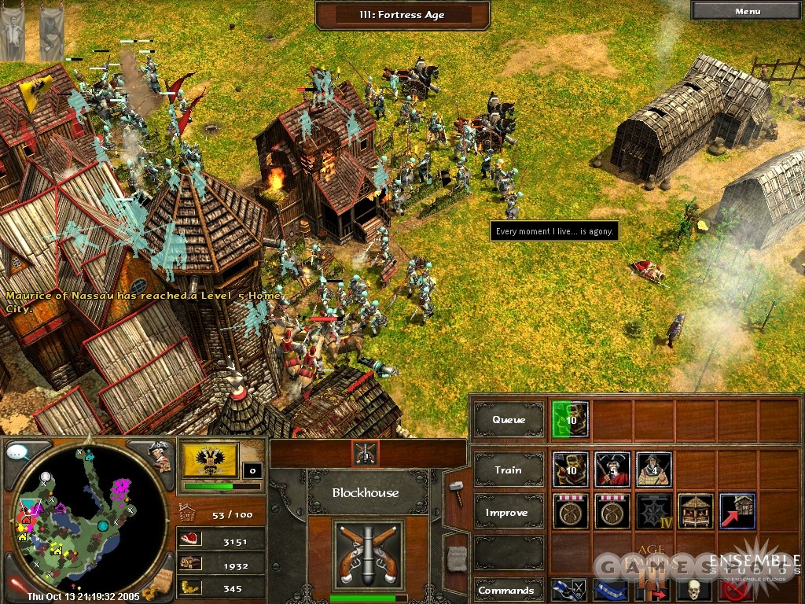

**THE SIMS SERIES**

The Sims is a life simulation video game series, developed by EA Maxis and published by Electronic Arts. The games in The Sims series are largely sandbox games, meaning that they lack any defined goals (except for some later expansion packs and console versions which introduced this gameplay style). The player creates virtual people called "Sims" and places them in houses and guides them through simulated lifestyles and that help direct their moods and satisfy their desires.

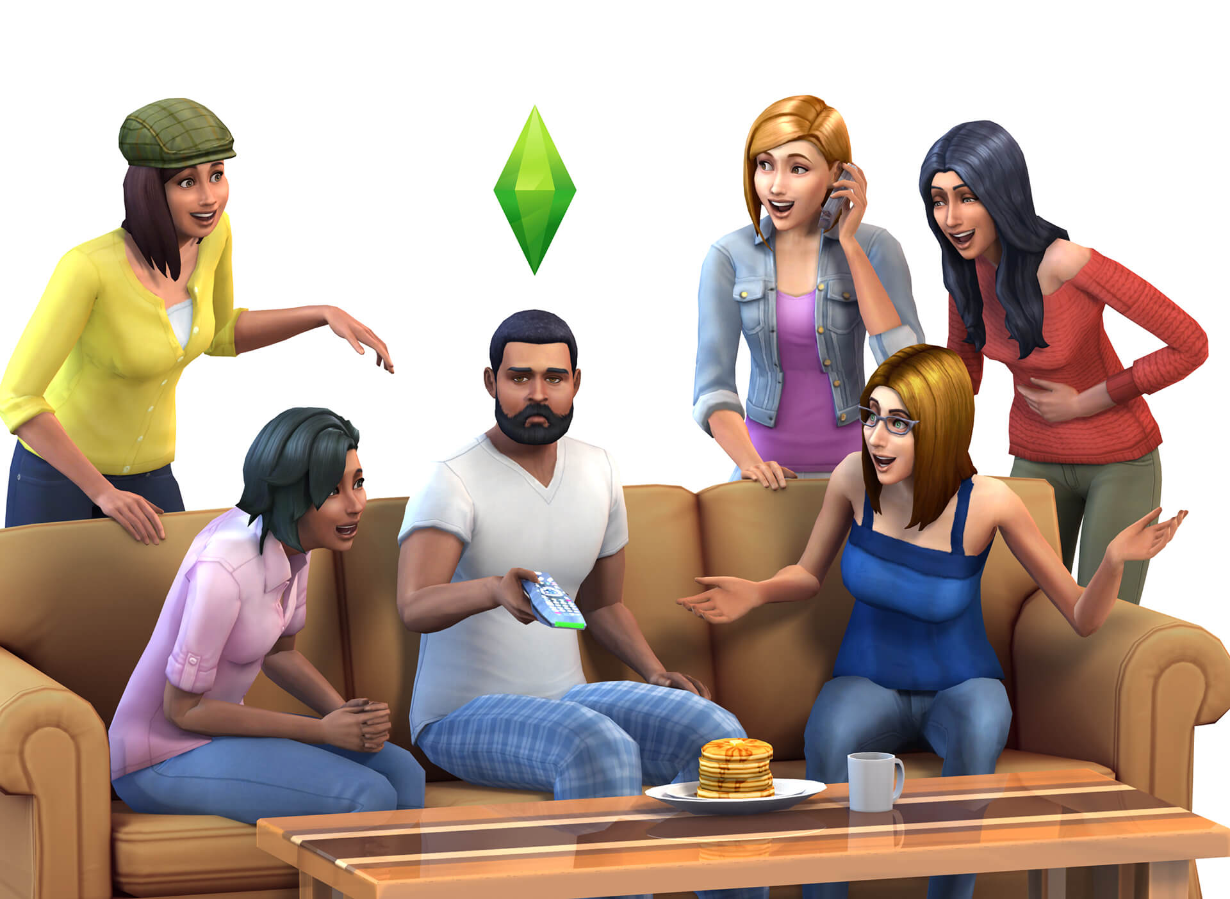

**SECOND PERSON SHOOTER ZATO**

By far the most obscure and strange game on the list, Second Person Shooter Zato, released by Japanese indie developer Himo in 2011, is a unique action game that puts you in control of a gun wielding hero that has to progress through a series of enemies. However, instead of the traditional first-person perspective, the player can only see himself through the eyes of the enemy, having the player play as if looking through a mirror.

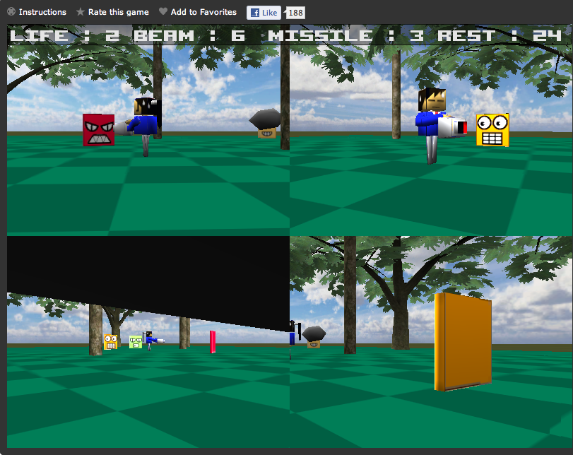

**VIRTUAL REALITY**

Virtual reality is the term used to describe a three-dimensional, computer generated environment which can be explored and interacted with by a person. That person becomes part of the virtual world or is immersed within this environment and whilst there, is able to manipulate objects or perform a series of actions.

**OCULUS RIFT**

Invented by a VR enthusiast named Palmer Luckey, the Oculus Rift is a set of virtual-reality goggles that will work with your gaming desktop or laptop. The Rift accomplishes virtual reality by using a pair of screens that displays two images side by side, one for each eye. A set of lenses is placed on top of the panels, focusing and reshaping the picture for each eye, and creating a stereoscopic 3D image. The goggles have embedded sensors that monitor the wearer's head motions and adjust the image accordingly.

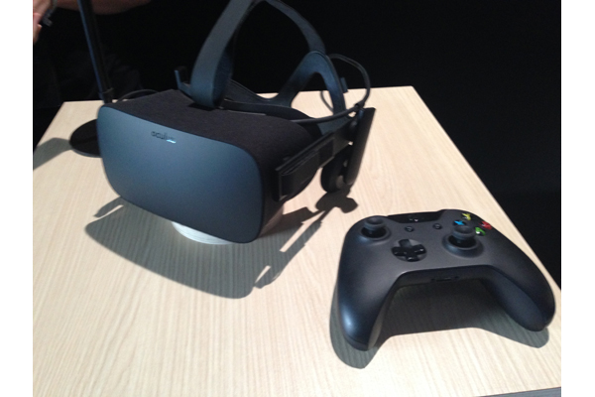

**GOALS AND OBJECTIVES**

Our goal is to create a functional, 3D role playing game that is compatible with both a standard television and an Oculus Rift. Our objectives will include the creation of fully rendered character models, from the main character to enemy character archetypes, all equipped with functional AI behavior that’s individually appropriate to each character’s given characteristic. We will also be creating a fully functional world with properly placed interactive objects and ambience to create a realistic atmosphere. The finished product will then be ported and properly integrated to fully functionally work with the Oculus Rift.

**ASSOCIATED OBJECTIVES**

The specific objectives are listed as:

1. Familiarize ourselves with unity and its applications.

2. Get familiar with downloading objects from 3d warehouse website and insert them into unity.

3. Get familiar with the way of coding in unity.

4. Get familiar with ray casting in unity.

5. Find software to do 3d objects in unity.

6. Create/find the main character 3d model and the enemy models.

7. Create two different levels of the game.

8. Implement the movement of the main character and the enemies.

9. Find a soundtrack for our game.

10. Implement the audio for the game (movement, attack, enemies sound).

11. Learn unity GUI system.

12. Create two different terrains for the game.

13. Make two functional versions of the game, one on pc and the other for Oculus Rift.

14. Check for other similar games and learn how they operate.

15. Learn how to make graphics as realistic as we can.

16. Test and debug the game.

**PROJECT ORGANIZATION**

The rest of the report will contain the following contents: Chapter II will contain detailed requirements analysis with both functional and non-functional requirements. Chapter III will describe architectural and detailed designs. Chapter IV will go into the design’s implementation. Chapter V will document the results. Chapter VI will finalize the report with the conclusion and discuss conceivable expansions of the project.